NAME: S.PRATIBA ROLL NO:241901080

EXP 9: PERFORM WEB APPLICATION
VULNERABILITY SCANNING

AIM:
To run an automated vulnerability scan against a web application and identify common security weaknesses such as security misconfigurations and missing HTTP security headers.
ALGORITHM:
- Start the Kali Linux environment and launch OWASP ZAP.
- Start the DVWA target application and access it at http://127.0.0.1:8081/.
- Log in to DVWA and set the security level to Low.
- In ZAP Quick Start, enter the target URL http://127.0.0.1:8081/.
- Enable the traditional spider and start the automated scan against the local lab target.
- Wait until ZAP displays “Attack complete” and indicates that results are available in the Alerts tab.
- Open the Alerts tab and review the findings and their risk levels.
- Select alerts to inspect the details and affected URLs where available.
- Generate the ZAP report in HTML format.
- Record the observed findings and report as the output of the experiment.
TOOLS REQUIRED:
- Kali Linux
- OWASP ZAP (Zed Attack Proxy)
- DVWA running locally in Docker

OUTPUT:
1. Automated Scan Completed
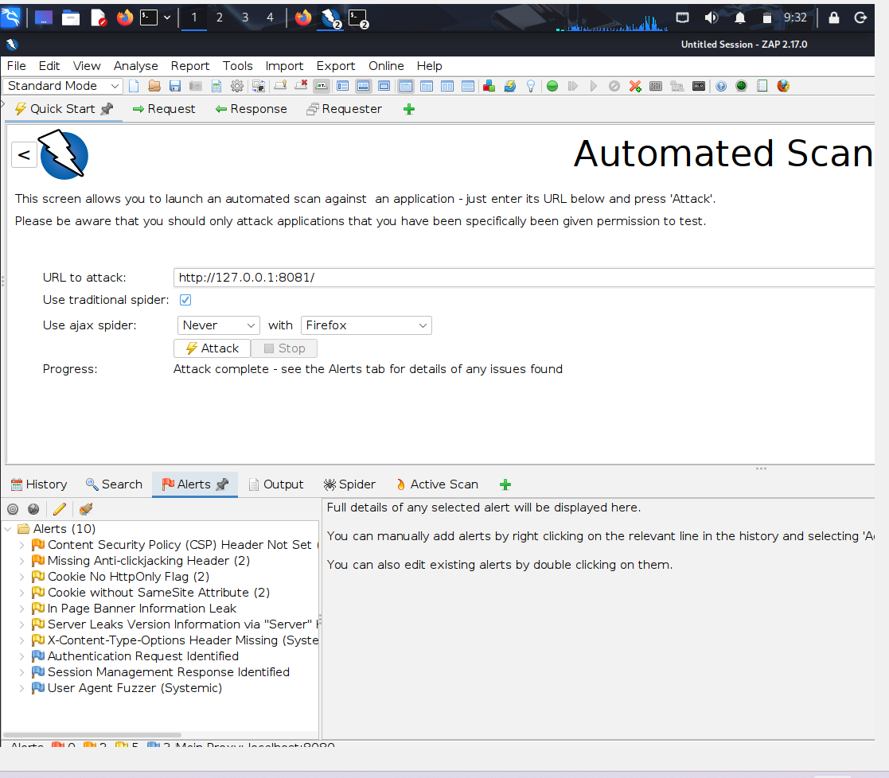
Fig 1: OWASP ZAP automated scan completed for the local DVWA target; the Alerts panel shows 10 alerts.

2. Alerts Tab
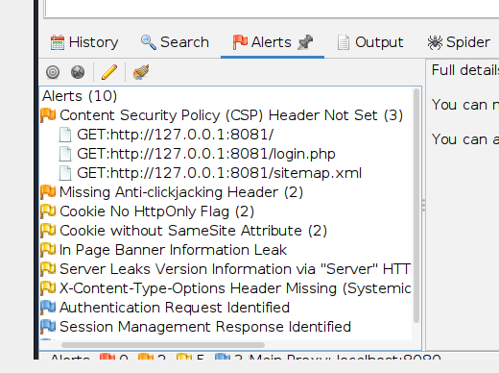
Fig: Actual ZAP Alerts tab showing the scan's detected alert categories, including CSP Header Not Set and missing security headers.
3. Generated HTML Report
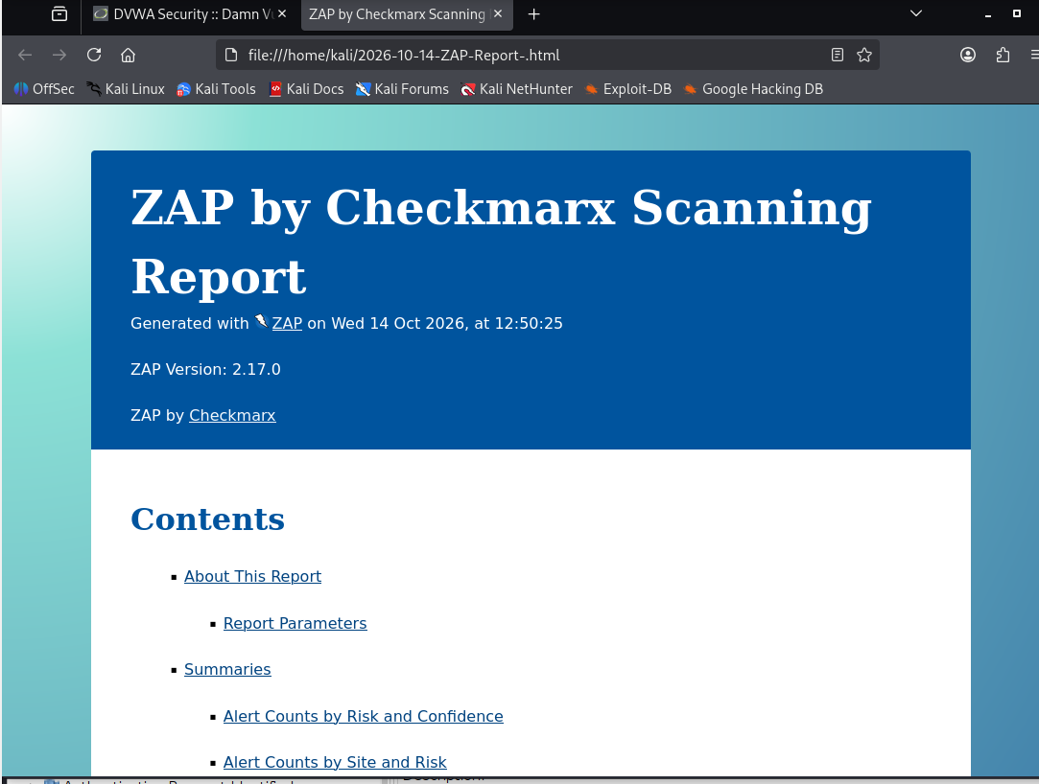
Figure 3: Actual ZAP HTML report opened in the browser, showing the report title, generation time, and ZAP version.
RESULT:
The local DVWA web application was scanned successfully using OWASP ZAP. The completed scan displayed 10 alerts, including a Medium-risk Content Security Policy (CSP) Header Not Set finding, Low-risk missing security-header and cookie-configuration findings, and Informational observations. The ZAP HTML report was generated successfully.

